I am listing all the changes that need to be made to the website.

Header Menu:

Home – About Us – Our Services – Countries – Partner With Us – Contact Us

The logo size needs to be adjusted. You may place the logo on the left side with the company name/text aligned properly on the right, or redesign the alignment to make it look more balanced and visually appealing, as the current placement appears slightly off.

Slide 1 – Immigration & Global Mobility
Badge:
Trusted by Thousands Worldwide

Your Global Future

Starts Here
Expert guidance for immigration, visas, and overseas opportunities designed to help you move forward with confidence.
Buttons:
- Check Eligibility
- Book Consultation
Bottom Stats:
- 5,000+ Successful Cases
- 10+ Years’ Experience
- 40+ Countries Served
- 98% Client Satisfaction

Slide 2 – Dubai Migration Consultancy
Badge:
Dubai-Based Immigration Experts

Smart Migration Solutions

Tailored for You
From profile evaluation to visa processing, our specialists provide transparent and reliable support for your international goals.
Buttons:
- Free Profile Assessment
- Speak to an Expert
Focus of this slide:
👉 Consultancy expertise + personalized support
(Not repeating “global future” or “career” messaging)

Slide 3 – Second Citizenship / Family Security
Badge:
Global Security & Freedom

Give Your Family

A Borderless Future
Unlock the benefits of second citizenship with greater mobility, financial flexibility, and long-term security for your loved ones.
Buttons:
- Explore Citizenship Options
- Schedule Consultation
Focus of this slide:
👉 Family security + second passport + wealth/freedom angle
(Completely different emotion from other slides)

Slide 4 – Skilled Migration & Careers
Badge:
Skilled Migration Pathways

Build an International

Career with Confidence
We help professionals secure skilled visas and work permits through strategic guidance, documentation support, and end-to-end assistance.
Buttons:
- Check Your Eligibility
- Start Your Application
Focus of this slide:
👉 Career growth + skilled professionals + work permits
(Not repeating family/security/consultancy messaging)

Just keep Our Immigration Services (No need of other writings)

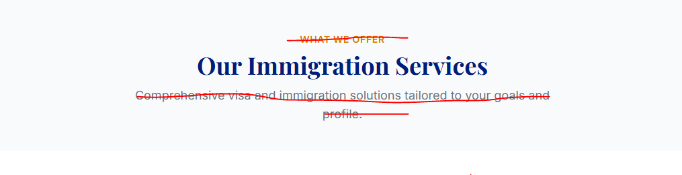

Just keep Where we can take you ( No need of other writings)



In the countries list bring Europe to First, then Canada, and add other countries.

Why Choose Us

1. Expert Immigration Advisors
Our experienced consultants understand complex immigration pathways and provide reliable solutions tailored to your goals.
We stay updated with changing policies to guide you with confidence and clarity.

2. Complete End-to-End Assistance
From eligibility assessment to documentation and final submission, we support you throughout the entire process.
Our team ensures a smooth and hassle-free immigration experience at every stage.

3. Tailored Migration Strategies
Every client’s profile is unique, which is why we create customized plans based on your background and aspirations.
We focus on identifying the best possible pathway for your success.

4. Dedicated Personal Guidance
We believe in personalized support, transparent communication, and one-on-one consultation for every applicant.
Our experts are committed to helping you make informed decisions with confidence.

Instead of client success stories, I want our process section.

Our Process

1. Initial Consultation
Connect with our immigration experts to discuss your goals, profile, and preferred destination.
We help you understand the best pathways available for your future plans.

2. Profile Evaluation
Our team carefully reviews your qualifications, work experience, and eligibility criteria.
This helps us identify the most suitable immigration program for your profile.

3. Documentation Assistance
We guide you through the complete documentation and verification process with accuracy and care.
Our experts ensure your application meets all required standards and compliance guidelines.

4. Application Processing
Once everything is prepared, we handle the submission and follow-up procedures efficiently.
We keep you informed throughout every stage of the application process.

5. Visa Success & Settlement Support
After approval, we continue assisting you with relocation guidance and next steps for a smooth transition.
Our goal is to help you begin your new journey with confidence and peace of mind.

Discover Your Best Immigration Pathway

Expert guidance tailored to your profile, goals, and international aspirations.
We analyze your background, qualifications, and experience to identify the most suitable visa and migration opportunities for your future abroad.
✔ Consultant-led profile assessment
✔ Strategic country and program recommendations
✔ Clear roadmap with transparent guidance
✔ Personalized support at every stage

Quick assessment response within 24–48 hours
👉 Start Your Assessment Now
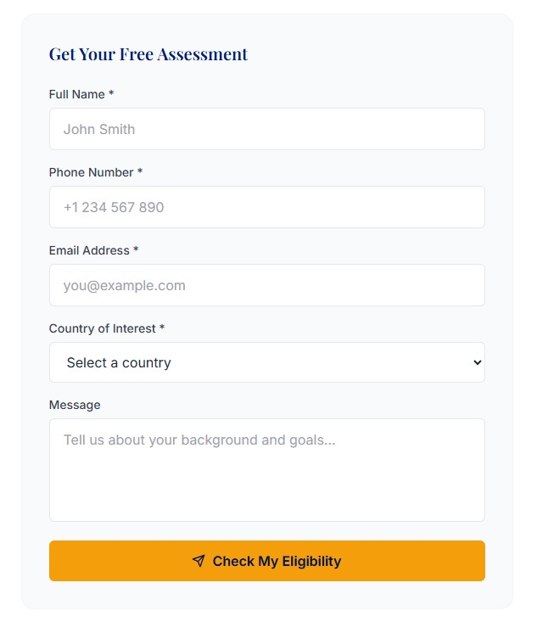
Belgium
Finland
Italy
Luxembourg
Netherland
Switzerland
Along with existing add these countries as well.

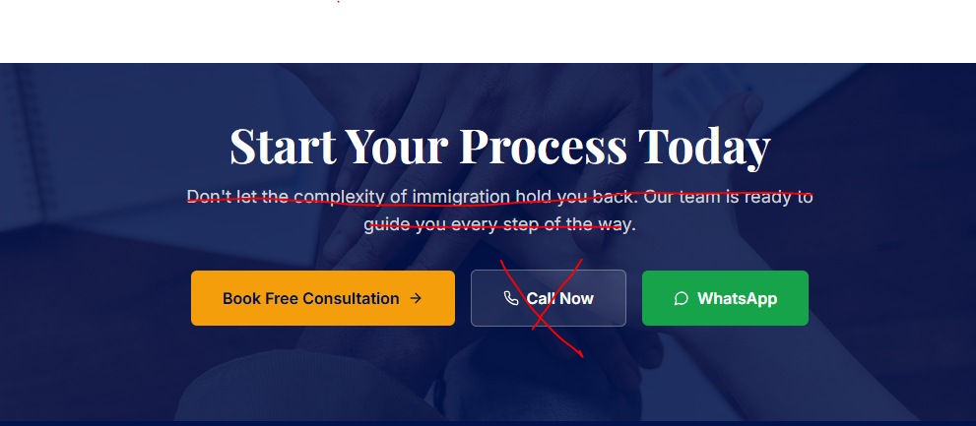

Just remove the heading and call now, keep book free consultation and whats app.

